Practical 5
Developing Web Service in .NET

To create an ASP.NET Web Application using ASMX Web Services to convert temperature from Celsius to Fahrenheit and Fahrenheit to Celsius.
Steps: -
- Open Visual Studio 2019.
- Click on Create a new project.
- Select ASP.NET Web Application (.NET Framework) and click Next.
- Enter the project details:
  - Project Name: WebServices
  - Location: As per requirement
Click Create.
- Select Web Forms as the project template.
- Set Authentication to No Authentication and click Create.
- After the project is created, right-click on the project name in Solution Explorer.
- Select Add → New Item.
- Choose Web Form, name it WebForm1.aspx, and click Add.
- Open WebForm1.aspx and switch to Design View.
- From the Toolbox, drag and drop the following controls:
  - Label → “Enter temperature in Celsius”
  - TextBox → ID: celbox
  - Button → Text: “Convert to Fahrenheit”, ID: ctof
  - Label → ID: fah
  - Label → “Enter temperature in Fahrenheit”
  - TextBox → ID: fahbox
  - Button → Text: “Convert to Celsius”, ID: ctoc
  - Label → ID: cel
- Double-click both buttons to generate click event handlers in WebForm1.aspx.cs.
- Right-click on the project name again.
- Select Add → New Item.
- Choose Web Service (ASMX), name it WebService1.asmx, and click Add.
- Open WebService1.asmx.cs and define WebMethods for Celsius to Fahrenheit and Fahrenheit to Celsius conversion.
- Open WebForm1.aspx.cs and create an object of WebService1.
- Call the Web Service methods inside the button click events and display the result in the respective labels.
- Save all the files.
- Click on Build → Rebuild Solution.
- Run the application by clicking Start (▶).
- Enter temperature values in the text boxes and observe the converted output.

UI: -
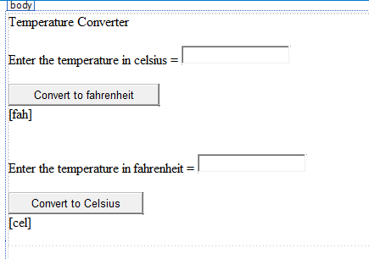

WebForm1.aspx.cs: -
using System;

namespace WebServices
{
public partial class WebForm1 : System.Web.UI.Page
{
protected void Page_Load(object sender, EventArgs e)
{
}

// Celsius to Fahrenheit
protected void ctof_Click(object sender, EventArgs e)
{
WebService1 t = new WebService1();

fah.Text = t.CelsiusToFarenheit(
Double.Parse(celbox.Text)
).ToString();
}

// Fahrenheit to Celsius
protected void ctoc_Click(object sender, EventArgs e)
{
WebService1 t = new WebService1();

cel.Text = t.FarenheitToCelsius(
Double.Parse(fahbox.Text)
).ToString();
}
}
}

WebService1.asmx.cs: -
using System.Web.Services;

namespace WebServices
{
[WebService(Namespace = "http://tempuri.org/")]
[WebServiceBinding(ConformsTo = WsiProfiles.BasicProfile1_1)]
public class WebService1 : WebService
{
[WebMethod]
public double CelsiusToFarenheit(double cel)
{
return (cel * 9 / 5) + 32;
}

[WebMethod]
public double FarenheitToCelsius(double fahr)
{
return (fahr - 32) * 5 / 9;
}
}
}

Output: -
